


Barnaby Bear’s Sensory Trail

Barnaby Bear’s Sensory Trail – AM or PM option
Children will meet Suntrap’s own Barnaby Bear, and decide what he needs to wear to go out into Epping Forest. They will follow a trail into the forest enjoying various sensory activities such as smelly cocktails and rainbow palettes. At the end of the trail they will make a mini shelter for Barnaby.

Some suggestions for visit preparation
1. Ask children to predict what they think it will be like in Epping Forest.
2. Discuss our senses and identify which part of the human body is associated with each sense.
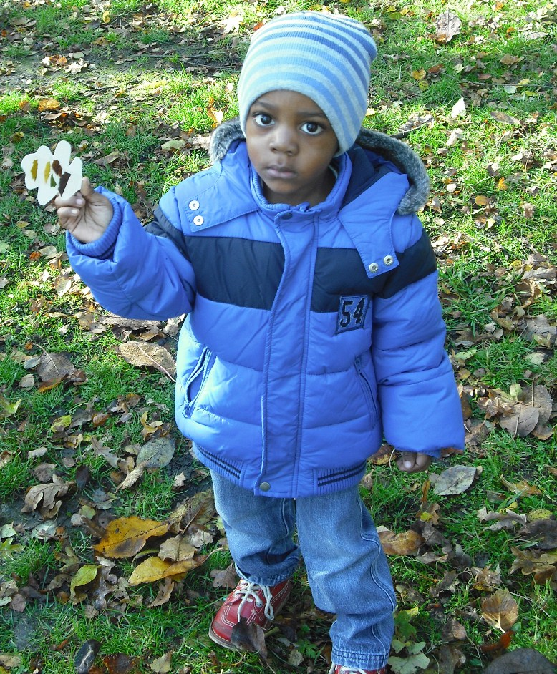

Follow on suggestions
1. Write and draw a postcard from Epping Forest to describe the environment.
2. Children draw pictures of themselves/ Barnaby Bear dressed for different weather conditions.

Learning objectives
- to have the confidence to try at least one new experience
- to be able to tell an adult about something have seen or touched in the forest

Early learning goal links
Communication and language
Give children opportunities to experience a rich language environment; to develop their confidence and skills in expressing themselves; and to speak and listen in a range of situations.
Physical development
Provide opportunities for young children to be active and interactive; and to develop their co-ordination, control, and movement.
Personal, social and emotional development
Help children to develop a positive sense of themselves, and others; to form positive relationships and develop respect for others; to develop social skills and learn how to manage their feelings; to understand appropriate behaviour in groups; and to have confidence in their own abilities.
Understanding the world
Guide children to make sense of their physical world through opportunities to explore, observe and find out about places and the environment.
Expressive arts and design
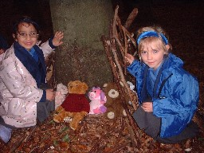
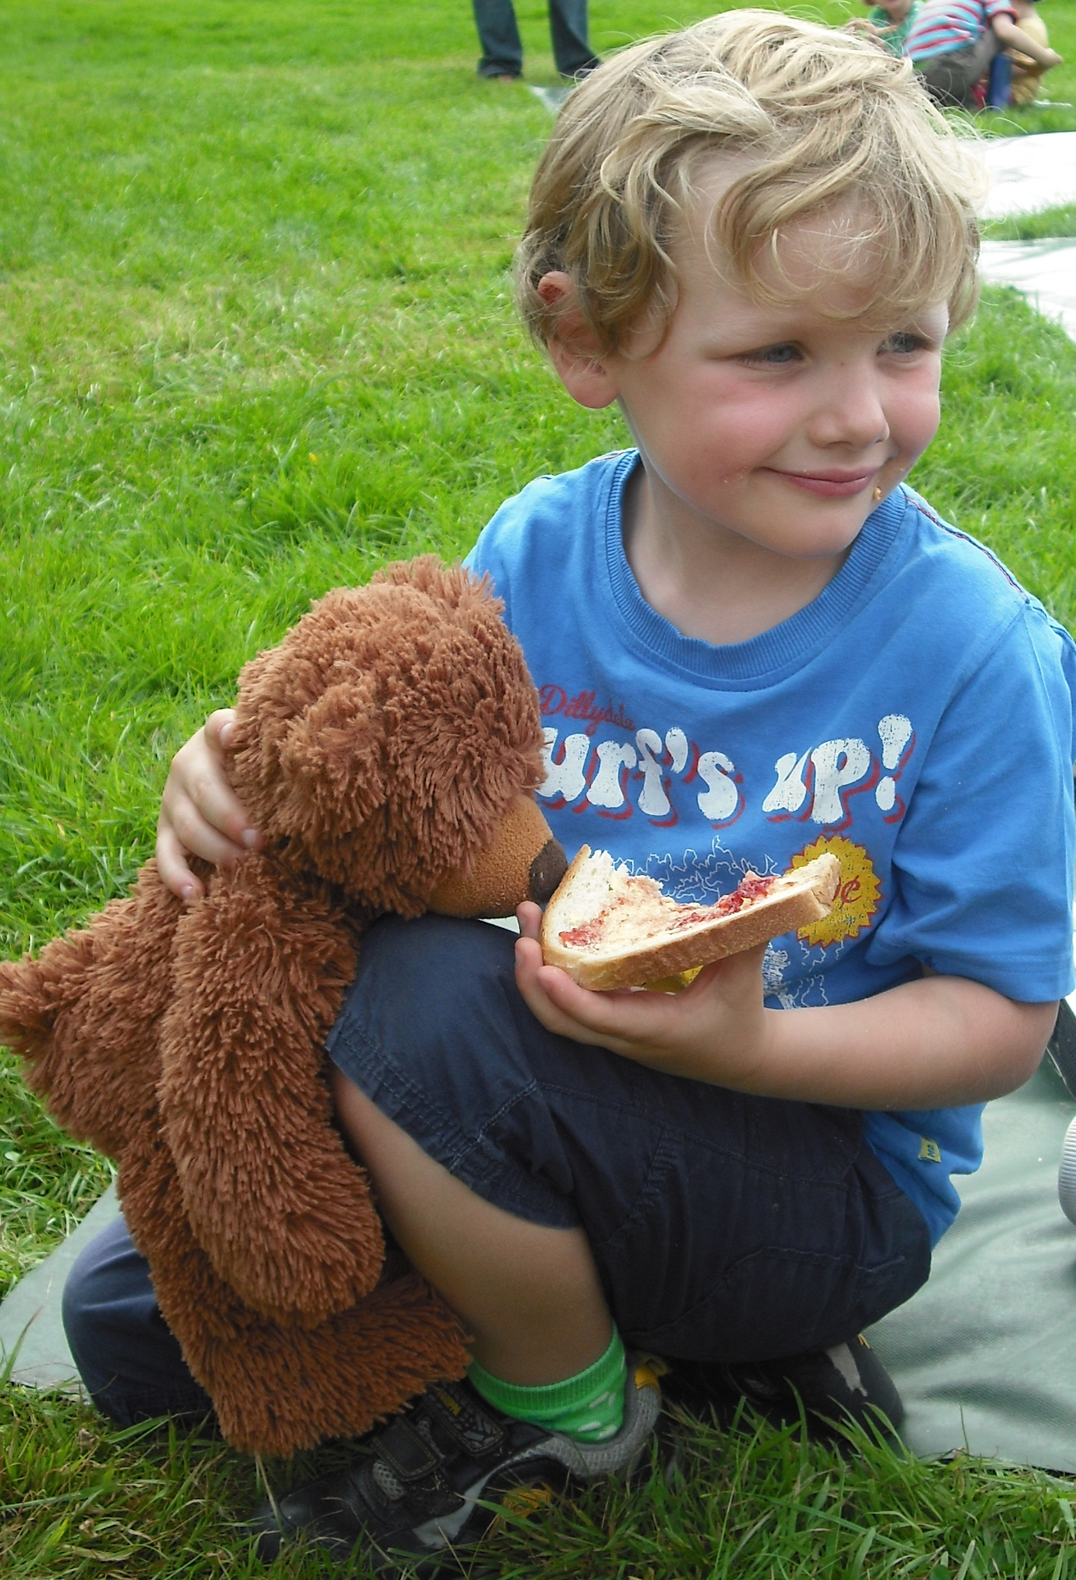
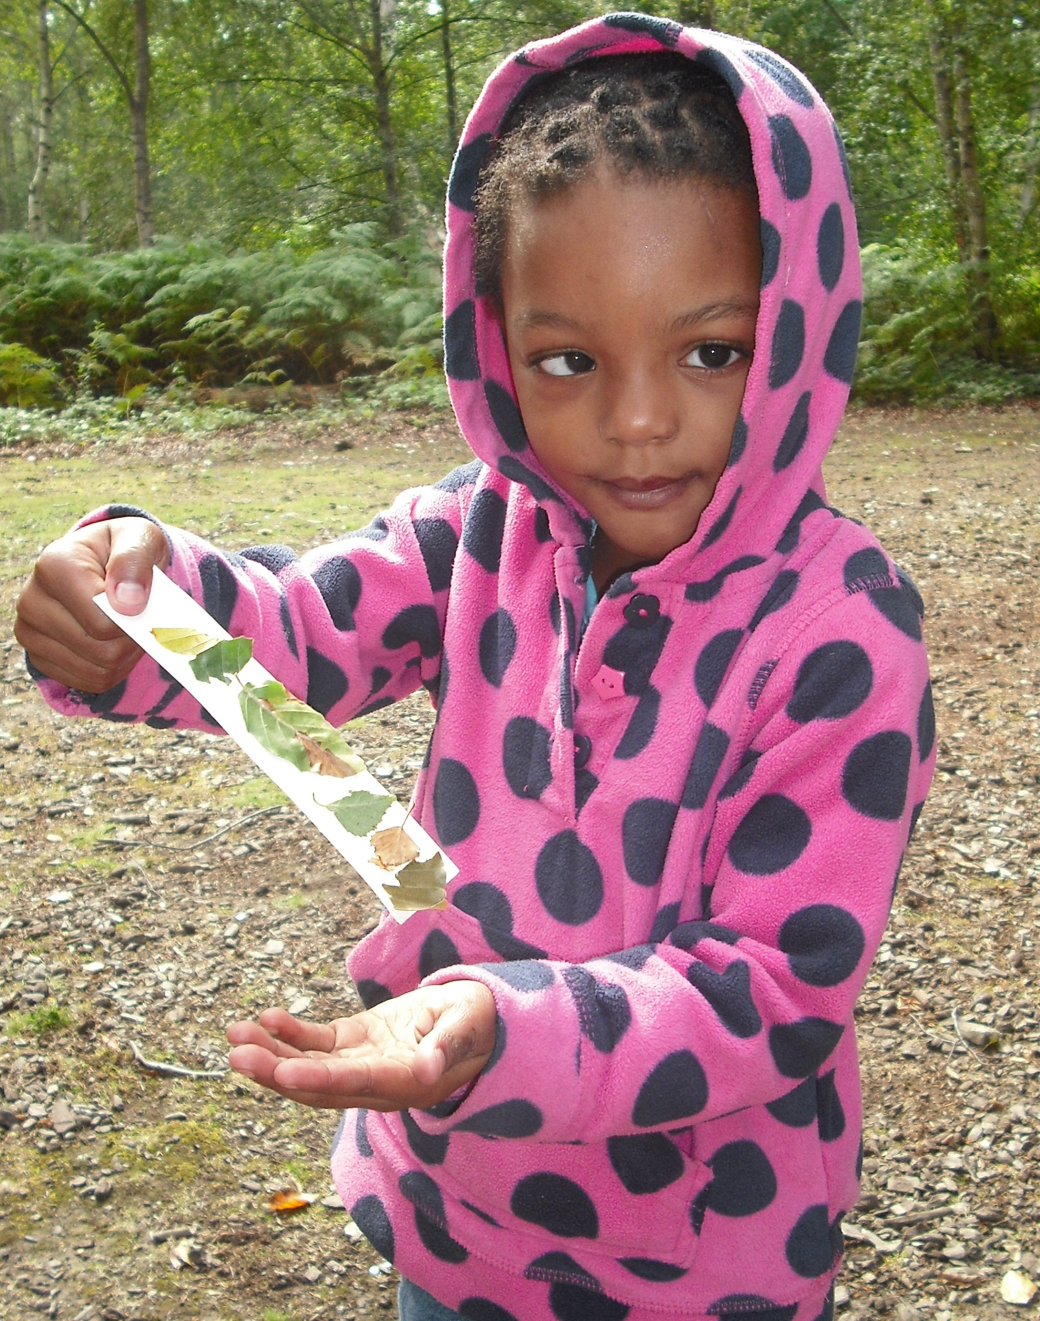
Enable children to explore and play with a wide range of media and materials, as well as providing opportunities and encouragement for sharing their thoughts and ideas.
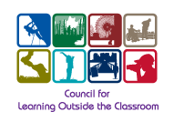
EVENT SPECIFIC RISK ASSESSMENT

Visit details: Barnaby Bear’s Sensory Trail Carried out by: Kerry Rolison Date: Dec 2016

Issue | How to manage it
Understanding/behaviour | Class teacher to advise Suntrap staff of any children who may need extra support out in the forest to help them to follow instructions.  School to ensure that there is appropriate adult: children ratios as required.
Medical conditions | Suntrap staff to check that school staff brings medication out into the forest.  All adults to be made aware of any medical conditions.  Suntrap staff will carry a first aid kit.
Getting lost | Keep within sight of teacher/adult & observe boundaries as directed by the staff.
Choking/Poisoning | No eating outside unless directly instructed by Suntrap staff.
Falling branches | During extreme weather conditions Suntrap staff will make an assessment to ensure it is safe to enter the forest.
Injury from horses/dogs or bikes | Group to be instructed to stand to the side, be quiet and still when horses, dogs or bikes are near.
Accident when crossing the road | Group to be instructed on follow safe procedures for crossing roads (Suntrap Line).  No one to walk across the cattle grid.
Injury through falling & throwing | Climbing of trees and throwing sticks/stones prohibited.
Deep water | Group to be instructed not to cross boundary to pond.  Teaching staff to remain observant when children are near water.
Soil borne disease | Children instructed not to put fingers in mouth during/after activities which include handling plants, soil and sticks.  Hands should be washed with warm soapy water before eating lunch/snack.
Injury from picking up branches/sticks | Children instructed not to pick up very big sticks alone.  Children should also have adequate space between others to prevent injury from long branches.
Stings/cuts from plants | Suntrap staff will point out plants that may cause injury to children and instruct them not to pick/touch them.

